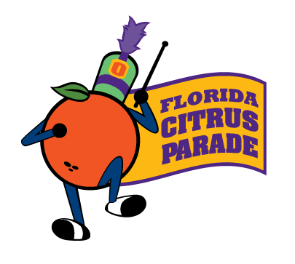

Florida Citrus Parade

Citrus Float Build

Held at the Orange County Convention Center

Citrus Float Build Volunteer Application

Contact Information

Group Name/Organization: ____________________________________________________________________________________

Volunteer Name: _________________________________________ Title: ______________________________________________

Home Phone: ___________________________________________ Work Phone: ________________________________________

Cell Phone: ____________________________________________ Email Address: ______________________________________

Mailing Address: ____________________________________________________________________________________________
Street
__________________________________________________________________________________________________________
City State Zip Code

Shift Information
Please indicate which shift(s) you or your group is interested in (include first and second choice), the number in your group per shift and the age range of the group:

shifts times number of volunteers age range

Monday, December 26, 2016 8:00 a.m - 11:00 a.m ____________________ _____________________
Monday, December 26, 2016 11:00 a.m - 2:00 p.m ____________________ _____________________
Monday, December 26, 2016 2:00 p.m - 6:00 p.m ____________________ _____________________
Monday, December 26, 2016 6:00 p.m – 10:00 p.m ____________________ _____________________
At Convention Center

Tuesday, December 27, 2016 9:00 a.m – 1:00 p.m ____________________ _____________________
Tuesday, December 27, 2016 1:00 p.m – 5:00 p.m ____________________ _____________________
Tuesday, December 27, 2016 5:00 p.m – 9:00 p.m ____________________ _____________________
At Convention Center

Wednesday, December 28, 2016 9:00 a.m – 1:00 p.m ____________________ _____________________
Wednesday, December 28, 2016 1:00 p.m – 5:00 p.m ____________________ _____________________
Wednesday, December 28, 2016 5:00 p.m – 9:00 p.m ____________________ _____________________
At Convention Center

**Volunteers must be at least 10 years of age. For larger groups, please make sure there is at least one adult chaperon for every 8 children.
Shifts tend to fill up early, so please send in your application as soon as possible. Upon receiving your application, we will contact you confirming your shift.

APPLICATIONS MUST BE RECEIVED BY DECEMBER 16, 2016
Continued on Back

Additional Information

How did you hear about this volunteer opportunity?

AAA Boy Scouts Disney VoluntEARS

Family/Friend FCSports Member Girl Scouts

Hands on Orlando Orlando Weekly Newspaper Volunteermatch.com

Other: ______________________________________________________________________________________

How many years have you been volunteering at the Citrus Float Build? __________________________________________

Please list any special concerns or suggestions: ____________________________________________________________
___________________________________________________________________________________________________
___________________________________________________________________________________________________

For more volunteer opportunities, please visit www.fcsports.com and click on the volunteer link.

please mail or fax completed application to:

Florida Citrus Sports
Attn: Parade Assistant
One Citrus Bowl Place
Orlando, FL 32805
Phone: 407.423.2476 Fax: 407.425.8451

